Aws task 2
Ayesha

Createda vpc and internet gateway
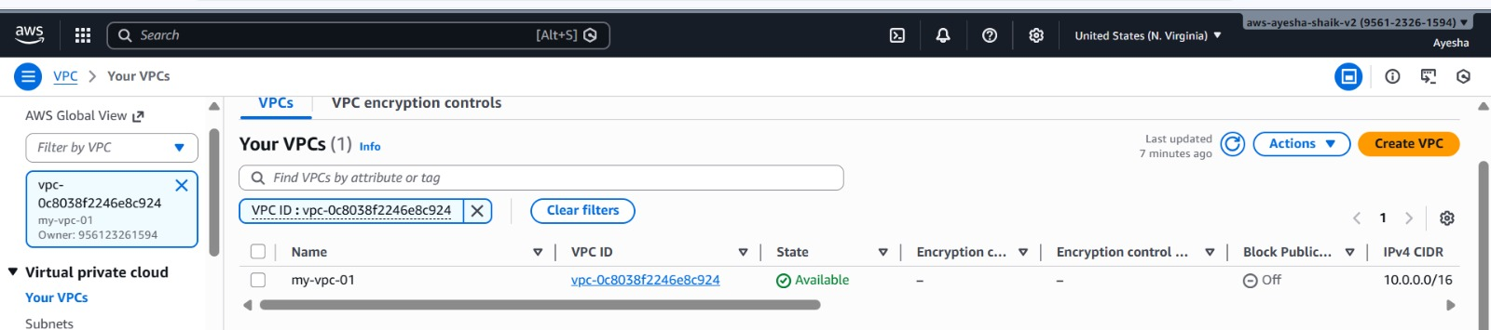
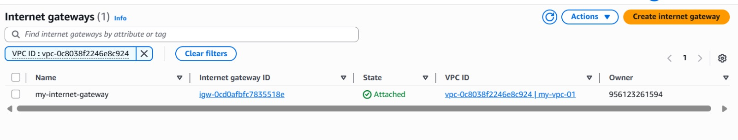

Created two subnets and named aspublic and private
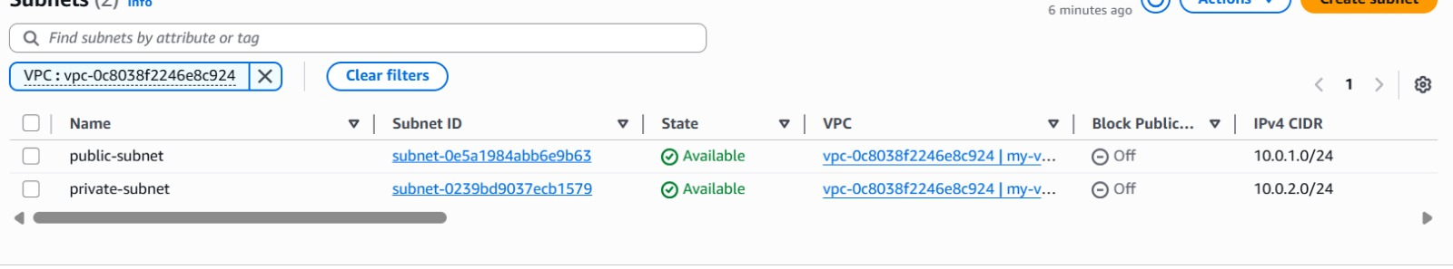

Now i have attached igw to routetable and added public subnet to routetable
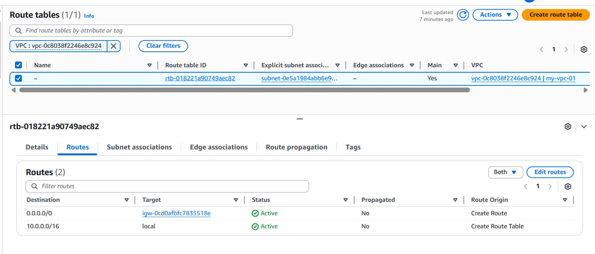
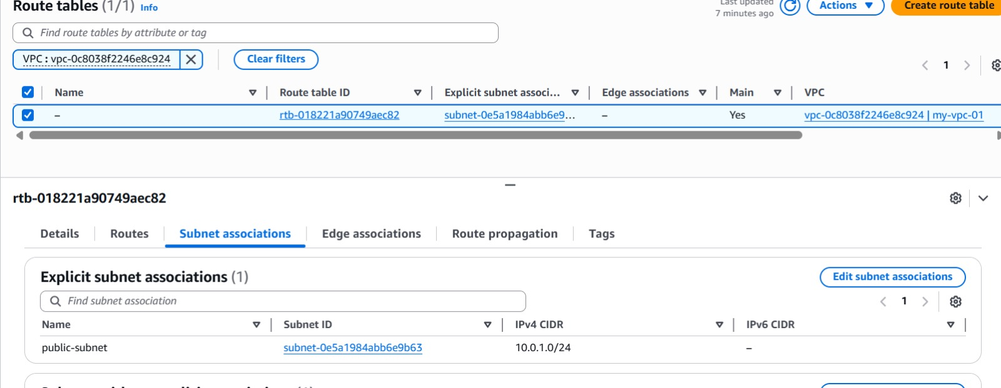

Created an instance in public subnet
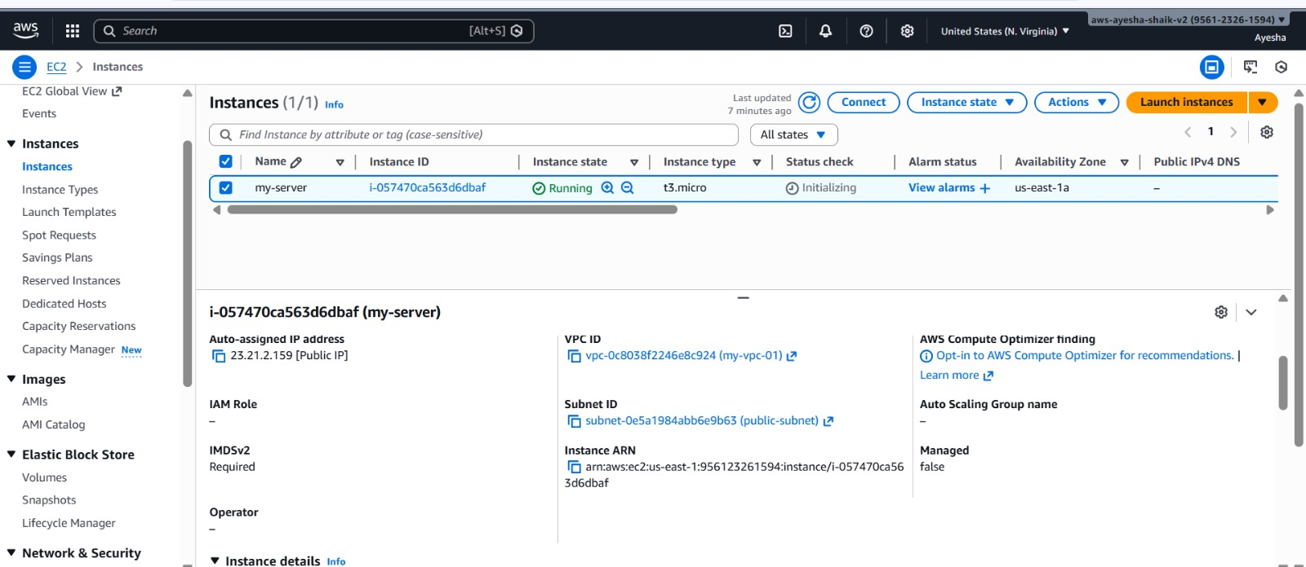

Logged into the instance
